# Lab 8 – Programming Structures in MATLAB

## Exercise

### Exercise 1

Write a program to check whether a given number is greater than or equal to 50, using if-else statement. Check the program with the given numbers (a) 23 (b) 50

**Code:**

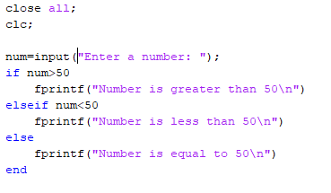

**Output:**







### Exercise 2

Write a program to evaluate y = 2x + 1 if x<5, otherwise y =2x. Use the if-else statement. Check the program with the value of x as (7) and (2)

**Code:**

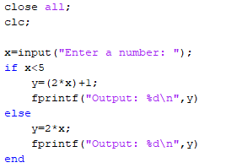

**Output:**





### Exercise 3

Write a program to find the largest of the three numbers using if-else if-else statement. Check the program with the given values (45,98,34) and (45,34,8)

**Code:**

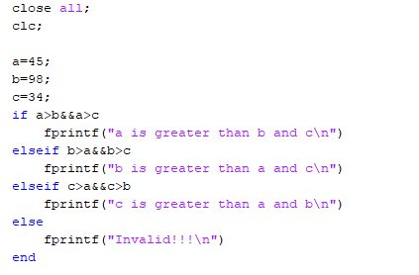

**Output:**



### Exercise 4

Use a for- loop to print out the square of integers from 1 up to maxValue (take input from user).

**Code:**

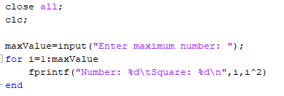

**Output:**

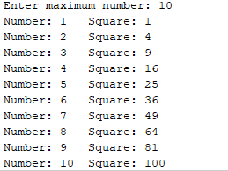

### Exercise 5

Use a while loop to calculate factorial (10)

**Code:**

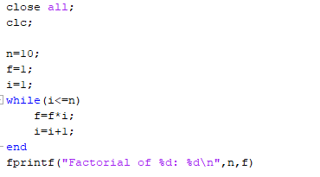

**Output:**

